**EOD Report (30/06/2022)**

The Processes that the system should prioritize are as follows:  
• Manage User Information  
• Records Information  
• Checks Existing Records  
• Registers New Record  
• Updates Information

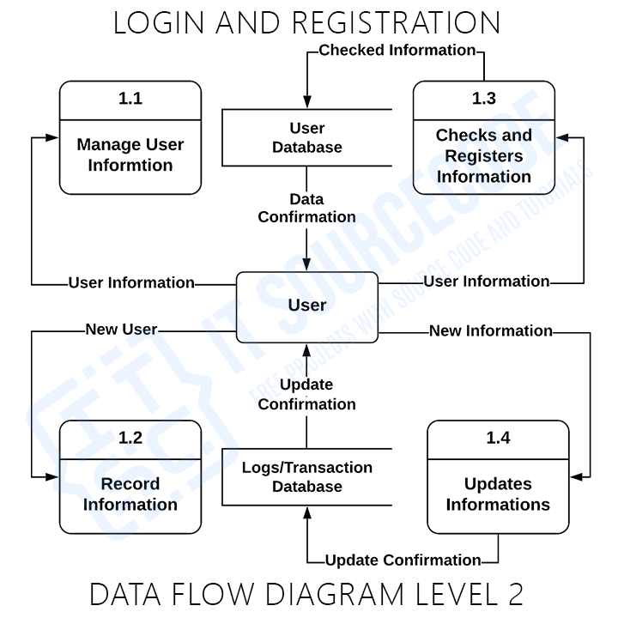

These procedures require information such as record of users, logs, transaction and other information from which served as the bases for the login admin to manage the Login and Registration. This type of data is represented by a data store.

**Reference: https://itsourcecode.com/uml/login-and-registration-dfd-levels-0-1-2-data-flow-diagrams/**